Dear [MP’s name]

Help unleash cooperative energy
The Government wants to unleash the biggest expansion in community energy in British history. This is a fantastic ambition which I wholeheartedly support. As your constituent, I am writing to you to ask for your help to enable cooperative energy to become a mainstream part of the UK’s energy mix.
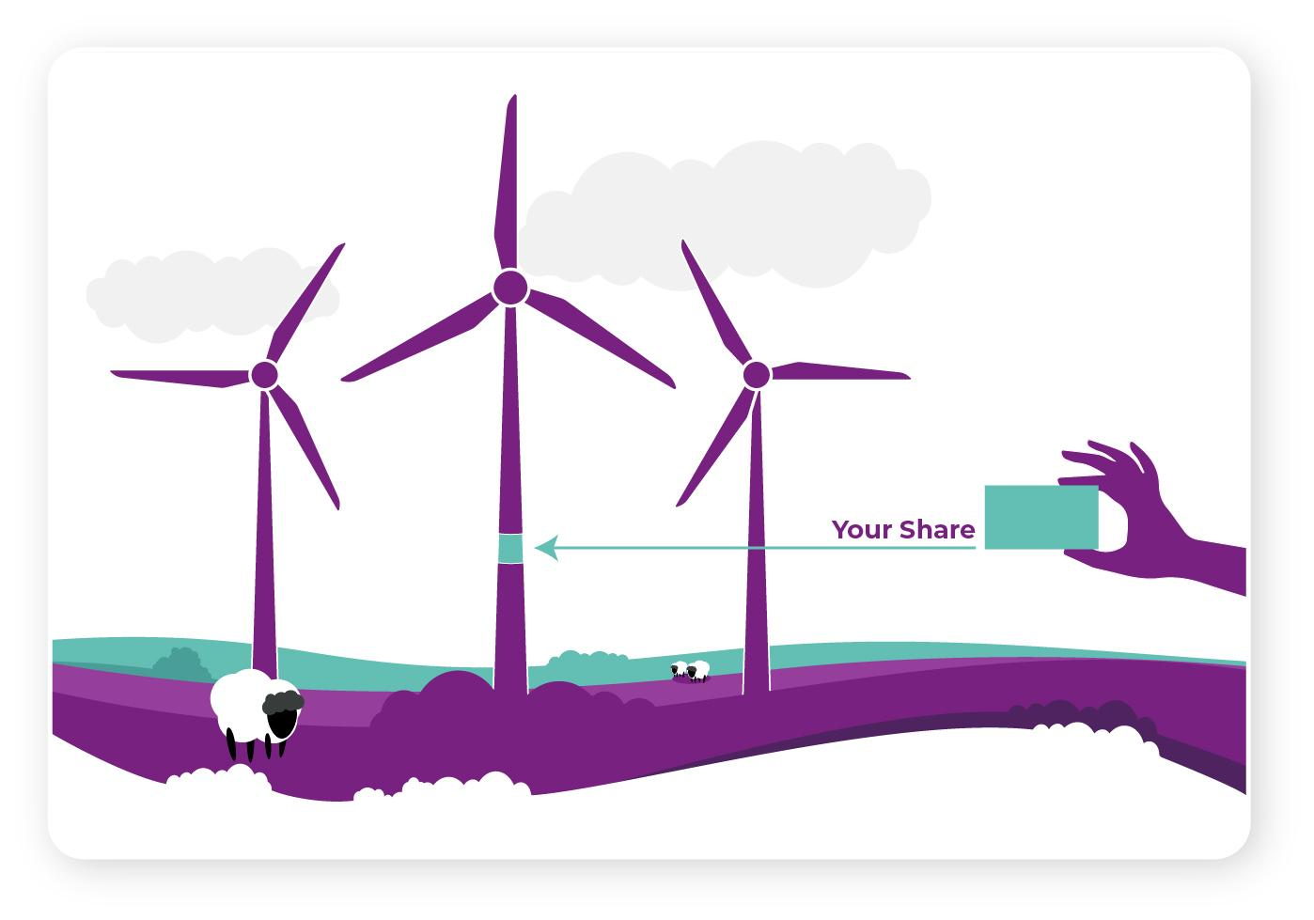
A typical household needs just a credit card-sized slice of a wind turbine to power it for 30 years, which costs around £2000.
Energy cooperatives are a great way to enable collective ownership of large-scale, low-cost sources of green power. They democratise energy ownership, protect against rising energy prices and enable people to play a real part in the UK’s exciting green energy transition.
I own a tiny slice of [insert project name in England/Wales/Scotland] via a cooperative managed by Ripple Energy. The electricity from [insert project name] is/will be supplied to me by my energy supplier and I / will get savings off my energy bill every month for its lifetime.
For cooperative energy to take off, it must be financially attractive for people to get involved. Members of energy co-operatives are currently penalised in two ways:
- Coop energy owners currently pay for green energy twice – once to build their own wind farm or solar park, then again to subsidise other people’s projects. Green energy levies are added to electricity bills to support renewable energy in Britain. People should not pay energy levies on electricity supplied to them from their own wind farm or solar park. A typical household could pay £2,000 to buy a share of a wind farm to supply their power, then pay a further £1,800 in levies to subsidise someone else’s wind farm. An exemption from the levies already exists but it requires the use of unlicensed energy suppliers or private wire networks. We want the exemption simplified so everyone who owns part of a large-scale wind farm or solar park cooperative can benefit.

- Bill savings from cooperative energy ownership can be liable to tax, as savings are treated as interest income for tax purposes. For some members, this reduces their bill savings by 40%. People with home solar benefit from tax relief on bill savings and income from their solar panels but there is no such tax relief if you own a wind farm or solar park as part of an energy cooperative.

The forthcoming Energy Independence Bill, announced in the King’s Speech, is an opportunity to remove the penalties faced by energy co-operatives and unleash the huge potential for community energy in the UK.

I ask you to support measures in the Energy Independence Bill to:
- Make a simple and accessible levy exemption for green energy ownership so electricity supplied from a household’s own wind farm or solar park is not subject to energy levies. This would more than double the bill savings and bring the payback period to around 7 years.
- Tax relief on electricity bill savings so co-op members do not pay tax on their bill savings.
- Low-cost loans for people on lower incomes via GB Energy. People on lower incomes are less likely to have access to the approx. £2000 needed to buy their credit card slice of a wind turbine. Access to low-cost loans would make ownership accessible to a far wider range of people.

To truly democratise energy ownership, it is also important energy co-operative are accessible to a wide range of people. These three simple measures will ensure members of energy cooperatives receive the full benefit from their renewable energy ownership. They would help bring down the payback period for ownership to under 10 years, which is crucial to ensuring co-operative energy is financially attractive for people.

As your constituent, I’m feeling really positive about what the future looks like for community energy – and I thank you for your party’s support to date. I’m now looking forward to what comes next with GB Energy, the Local Power Plan and The Energy Independence Act. I’m grateful you’ve taken the time to hear how much I care about this topic and what more can be done to unleash the true potential of community energy.
If you would like further information or a briefing on the subject please email Ripple Energy at info@rippleenergy.com. They would be happy to share the briefing and answer any questions you might have.

Yours sincerely

[your name]
[your address]

